9/25/2022

PF Lab Assignment

Lab#05

Abdullah Shafiq

22k-4489

**TASK 01**

Write a C program to check whether a number is multiple of 3 or not. If it

is then print “This number is multiple of 3”, otherwise print “This number

is not multiple of 3”.

PROGRAM & OUTPUT:

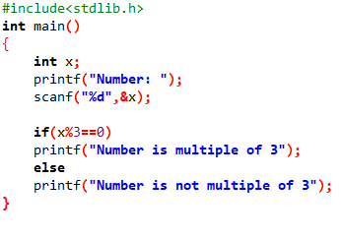

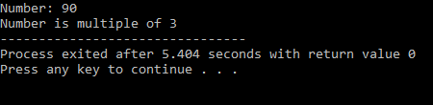

**TASK 02**

Write a program to see greeting according to time using 24-hour format

if time between is 5 to 11 it should greet “Good Morning”, if time is

between 12 to 18 it should greet “Good Evening”, if time between 18 to

24 it should greet “Good Night”.

PROGRAM & OUTPUT:

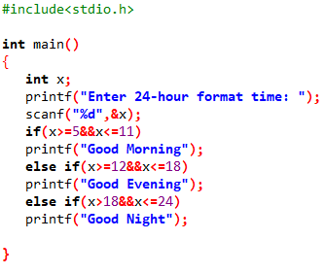

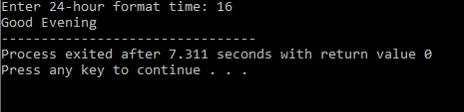

**TASK 03**

You must have seen the question before deleting anything like “Are you

sure to delete [Y/y] / [N/n]? Create a program that asks for this question

if user enters Y or y it prints “Deleted successfully” if the user enters N or

n it prints “Delete cancelled” otherwise it prints choose the right option

using switch statement.

PROGRAM & OUTPUT:

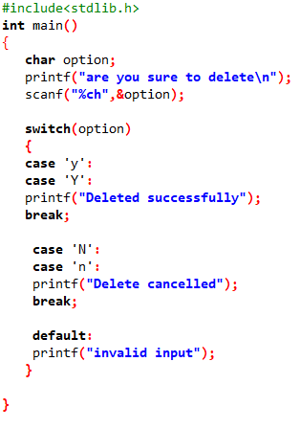

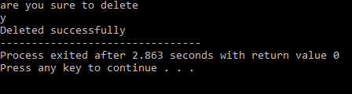

**TASK 04**

Create a calculator asking for operator (+ or – or * or /) and operands and

perform calculation according to the user input using switch statement.

PROGRAM & OUTPUT:

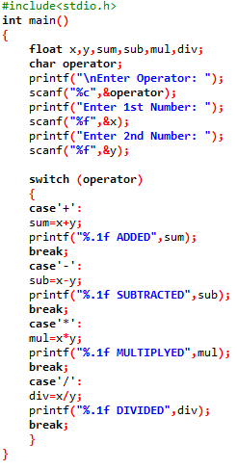

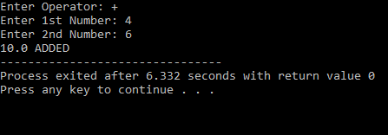

**TASK 05**

Write a C program to input a character from user and check whether given

character is small alphabet, capital alphabet, digit or special character,

using if else.

PROGRAM & OUTPUT:

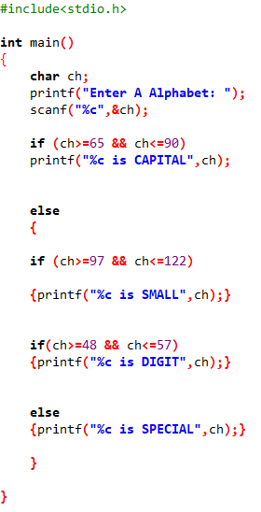

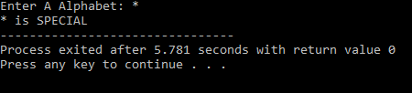

**TASK 06**

Create a program that requests a person's NIC number in order to register

them in a government housing scheme option. If no NIC number is

provided, the message "The person does not want the scheme" should be

displayed. If NIC is entered, a String stating "The person on the registered

NIC has been included in the government scheme" should be provided.

PROGRAM & OUTPUT:

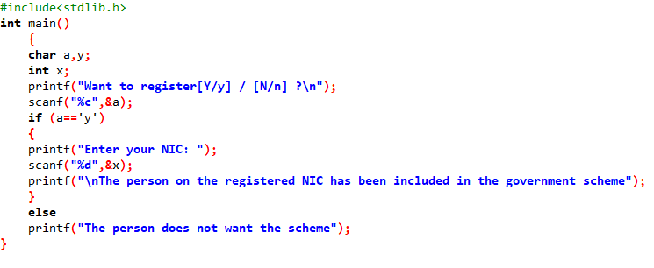

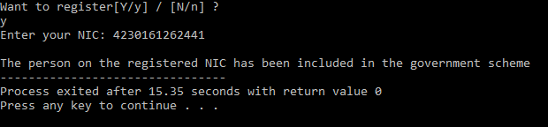

**TASK 07**

An online shopping store is providing discounts on the items due to the

Eid. If the cost of items is more than 1999 it will give a discount up to 50%.

If the cost of shopping is 2000 to 4000, a 20% discount will be applied. If

the cost of shopping is 4001 to 6000, a 30% discount will be applied. If it's

more than 6000 then 50% discount will be applied to the cost of

shopping. Print the actual amount, saved amount and the amount after

discount.

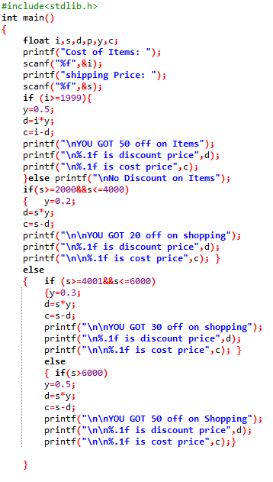PROGRAM & OUTPUT:

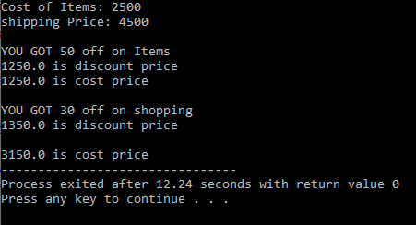

**TASK 08**

An android developer wants to design a mobile feature to control the

brightness of the mobile phone according to the surrounding light. In

order to do it he uses an ambient light sensor (for the detection of

surrounding light) which is commonly built in in all latest android phones.

It gives the value of light intensity in integers. Write a C program for Light

sensor value ranges from 0-1000, if it's exposed under sunshine (>500), if

it's evening then (0 ~ 100), lighting (100 to 500).

PROGRAM & OUTPUT:

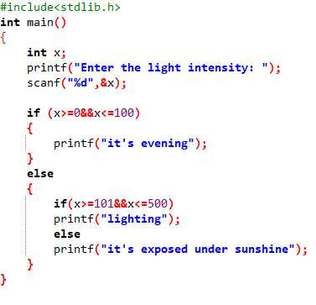

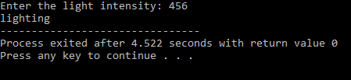

**TASK 09**

Write a C program to find all roots of a quadratic equation, it is required

to take user input for a, b and c values. Find discriminant using formula

discriminant = (b × b) − (4 × a × c)

Compute roots based on the nature of discriminant.

PROGRAM & OUTPUT:

